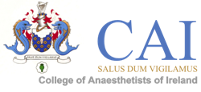

# **Fellowship Clinical/SOE Preparation Course**

**Date:** 13th March 2025, 9am-4pm

**Venue:** Chartered Accountants of Ireland

**Price:** €390.00

Please complete the form in block capitals or in typed formaT

**This form should be emailed to** [**exams@coa.ie**](mailto:exams@coa.ie)

College ID:

Name:

Surname:

Address line 1:

Address line 2:

Address line 3:

Town/City:

Country:

Eircode:

Mobile number (including country code):

Email Address:

SAT Trainee: Yes  No

Repeat: Yes  No

Candidate’s Signature: ____________________ Date: Click or tap to enter a date.