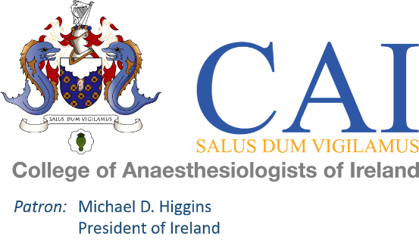

**Election to the Council**

**Of**

**College of Anaesthesiologists of Ireland**

**2025**

|  |
| --- |
| Candidate Information |

Candidate Name: ___________________________________________________________

Medical College: ___________________________________________________________

Year of Graduation: ____________________

FCAI: ____________________

Present Appointment: ___________________________________________________________

___________________________________________________________

___________________________________________________________

___________________________________________________________

___________________________________________________________

Personal Statement:

|  |
| --- |
|  |

Nominations for election must be received before **5pm on Tuesday 11th February 2025.**

A Fellow desirous of a seat on the Council shall, before **5pm on Tuesday 11th February 2025** transmit/deliver to the Honorary Secretary, a notice signed in the following terms, and also forward

1. Date and Place of basic qualification
2. Date of Fellowship
3. Present Appointment

“I....................................................................................................................................................................of.............................................................................................................................................................................................................................................................................................................................................

Fellow of the College of Anaesthesiologists **In Good Standing**, do hereby declare that I am a candidate for a seat on the Council of The College of Anaesthesiologists of Ireland.”

“We, the undersigned Fellows of The College of Anaesthesiologists **In Good Standing**, do hereby certify that:

.......................................................................................................................................................................of.............................................................................................................................................................................................................................................................................................................................................

Is in our estimation a fit person to be elected to the Council of The College of Anaesthesiologists of Ireland and we do hereby nominate him/her as a candidate for a seat on said Council.”

Signature........................................................ Print.......................................................................

(Block Capitals Please)

Signature........................................................ Print.......................................................................

(Block Capitals Please)

**Dr Deirdre McCoy**

**Honorary Secretary**

**College of Anaesthesiologists of Ireland**

**22 Merrion Square North**

**Dublin 2**